# Lab 3:

**Program Branching, Lookup Tables, Timers, Interrupts**

**Name:**

**Give brief answers to the following questions. You can edit this document and insert your answers after each question,**

**Due dates:**

**MW – Wed, Feb 21, beginning of class  
TTH – Tue, Feb 20, beginning of class**

1. (1 pt) There is a discrepancy between one of the labels in Figure 7-1 on page 55 of the datasheet and the register bit table for Register 7-1 on the same page. What is the discrepancy? Which is correct, the figure or the register bit table? (Hint: the correctness can be determined looking in the P16F877_inc_copy.txt file.) Moral of the story: data sheets can have errors.  
     
   **Ans.**

T2OUTPS3 🡪 TOUTPS3

The right once which is in the header file and REGISTER 7-1 is correct.

1. (1 pt) Which register is copied to W with the instruction movf PIR1, W if:

PIR1 = 0x0c = 0000 1100  
a) STATUS = 0x00 🡪STATUS: 0000 0000 🡪 W = 00 000 1100 🡪 0x0c 🡪 PIR1  
b) STATUS = 0x20 🡪STATUS: 0010 0000 🡪 W = 01 000 1100 🡪 0x8c 🡪 PIE1  
c) STATUS = 0x40 🡪STATUS: 0100 0000 🡪 W = 10 000 1100 🡪 0x10c 🡪 EEDATA  
d) STATUS = 0x60 🡪STATUS: 0110 0000 🡪 W = 11 000 1100 🡪 0x18c 🡪 EECON1  
  
**Ans.**

1. (1 pt) What is value of the W register (in hex) after the following instruction: movlw  D’381’ ? What warning number and message does the assembler generate when it assembles this instruction?  
     
   **Ans.**Argument out of range, Least significant bit used

D’381’ = 10 (STATUS) + 111 1101(W)

W = 111 1101STATUS = 0x40

1. (1 pt) Suppose PORTC = 0011 1100 and STATUS<C> = 1. What will be the contents of PORTC and STATUS<C> after the instruction rrf PORTC, F?   
   **Ans.**

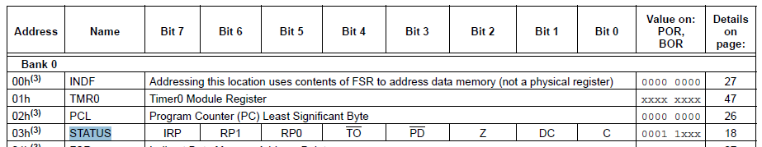

PORTC = 0001 1110

STATUS<C> = 0

1. (1 pt) In the lab03_LookupTable.asm code, the following line occurs at the beginning of the code:  
     
   list p = 16f877  
     
   Why can we use the “=” symbol even though it is not one of the PIC’s instructions? (Hint: See Table 3.4 in the MPASM User Guide.)  
     
   **Ans.**   
   since = means set equal to and 16f877 is set into the p and it is one of the legal actions  
   this is a directive rather an instruction thus this symbol is allowed
2. (1 pt) Build the lab03_LookupTable.asm code. Under the Edit/Properties menu, make sure the following dialog is set as shown below..   
     
   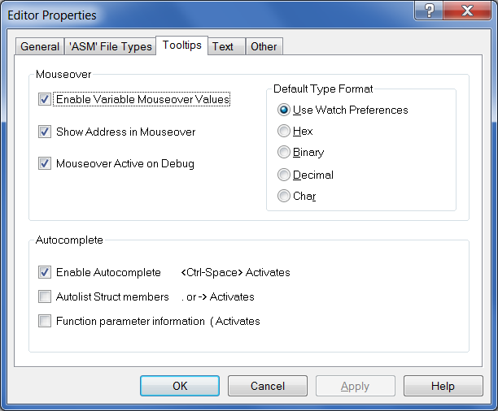  
     
   a) Note that TableSize is set equal to 4. Mouseover TableSize. What message do you see?  
     
   **Ans.**Addr = 0x004 TableSize = 0x90  
   b) Open the File Registers dialog and notice that TableSize is not listed. In which register is 0x90 being stored? Why?  
     
   **Ans.**  
   FSR

The reason that the value is stored in FSR is that table Size is used with EQU directive and the number 4

1. (2 pts) In the Instruction Summary the instruction decf is listed with two arguments:  
     
   decf f, d  
     
   If the destination bit is omitted, the code will still compile. In the lab03_LookupTable.asm code, insert the instructions below after the INIT label, build the code, and program the chip. Step the program until the two instructions are executed. Mouseover TableSize and compare the value of TableSize with the value of W in the status bar at the bottom of the window.  
     
   movlw 0x5  
     
   decf TableSize  
     
   a) What values are in TableSize and the W register (in hex)? What is the default destination, F or W?  
     
   **Ans.** TableSize = 0x90 🡪 0x8F  
    W = 0xC4 🡪 0x05  
    Default = F  
     
   b) Now include the W destination bit in the decf instruction and repeat Part (a). What values are in TableSize and the W register?  
     
   **Ans.** TableSize = 0x90 🡪 0x90  
    W = 0xC4 🡪 0x05 🡪 0x8F
2. (1 pt) Suppose the instruction movlw TRISA were added to the lab03_LookupTable.asm code immediately following the INIT label.  
     
   a) What would the W register contain (in hex) after the instruction executes and why?   
     
   **Ans.**

0x85 = 1000 0101

Since it only copies the 8 LSBs into W register and TRISA is B 1000 1001  
b) If the instruction movf TRISA, W were added to the code immediately following the INIT label, what would the W register contain (in hex) after the instruction executes and why?  
  
**Ans.**  
W = 0 since this is not a valid arithmetic

The w register contains 0. Value of TRISA and PORTA are identical for movlw instruction. Since bank 0 is selected the value of PORTA is selected and the content of PORTA is copied into W

1. (1 pt) In the lab03_LookupTable.asm code, insert the following dt directive after the INIT label and build the code:  
     
   dt 10, 20, 30  
     
   Open the Program Memory dialog. What code did the dt directive produce?  
     
   **Ans.**

It generates three instructions retlw 0x10, retlw 0x20, retlw 0x30,

1. (1 pt) What is the opcode for the instruction movlw 0xE5 ? Give your answer in binary and hex. For the binary, separate into nibbles for easier reading. (Hint: See the instruction description for movlw.)  
     
   **Ans.**  
   Binary: 11 00xx 1110 0101

Hex: 0x30E5

1. (1 pt) What is wrong with the syntax of the instruction incf PORTC, 2?  
     
   **Ans.**

2 is not valid. It can be either 0 or 1

1. (1 pt) What are the contents of the W register (in hex and binary) and STATUS<Z> after the instructions in the following code?   
     
   movlw 0xD8   
   xorlw 0xFF  
     
   **Ans.**   
   0xD8 = 1101 1000 xor 1111 1111 🡪result 0010 0111 W = 0010 0111 hex:27 🡪 W!=0 🡪 Z=0 Z = 0
2. (1 pt) What are the contents of the Count and W registers (in binary) and STATUS<Z> after the instructions in the following instructions?  
     
   movlw 0xD8 W=1101 1000  
   movwf Count count=101 1000  
   comf Count, W  
     
   **Ans.**   
     
   Count = 1101 1000  
    W = 0010 0111  
    Z = 0 since W != 0
3. (1 pt) What are the contents of the W register (in binary) and STATUS<Z> after the following instructions execute?   
     
   movlw D’100’ 0110 0100  
   andlw 0x88 1000 1000  
   **Ans.**

W = 0000 0000

Z = 1 since W=0

1. (1 pt) What instruction will be executed after the btfsc instruction in the following code? What are the values of W and STATUS<Z> after the following code executes?  
     
   movlw 0x81  
   addlw 0x7F  
   btfsc STATUS, Z  
   goto label_A  
   goto label_B  
   **Ans.**  
   the result of addlw is 256 which is over the limit so it overflows to 0 and Z bit is set

since Z=1 next instruction is executed whick is Label_A

1. (1 pt) Suppose Bank 2 is selected.   
     
   a) What are the contents of W (in hex) after the following instruction? (Hint: see the PIC16F877.inc on the resources folder.)  
     
   movlw EEDATA  
     
   **Ans.**

EEDATA is H’010C’ which is 0000 0001 0000 1100. Only the first 8 bit on the right side would move to W which is 0000 1100 or 0x0c  
b) Suppose Bank 3 is selected. What are the contents of W (in hex) for the same instruction?  
  
**Ans.**

It should technically get the data from the location of EEDATA in bank 3 which is EECON1. Thus the result should be the default value of EECON1 which is 1000 1100. However, when I run the program and run it in the debugger, the default value of EEDATA is moved to W which is 0000 1100

1. (1 pt) Suppose the oscillator frequency is 8 MHz, PR2 = 117, and T2CON = 0101 0011. What is the time (in milliseconds) between Timer2 interrupts?  
     
   **Ans.**Frequency = 8 MHz 🡪 Tosc = 1/8MHz = 0.125 us

T2CON = 0101 0011

* T2CKPS1:T2CKPS0 = 11 🡪 Prescalar = 16
* TOUTPS3:TOUTPS0 = 1010 🡪 Postscalar = 11

Timer2 interrupt = (Prescaler) (PR2 + 1) (Postscaler) (4 Tosc) =

= (16) (117+1) (11) (4 x 0.125 us)  
 = (16) (117+1) (11) (0.5 us ) = 10.384 ms

1. (1 pt) Suppose W = 5, and program memory address 0x008E executes an addwf PCL, F instruction. What program memory address (in hex) will execute next?  
     
   **Ans+**

PCL = PCL + W + 1 = 0x008E + 0x5 + 0x1 = 0x94

1. (1 pt) In the lab03_Timer2.asm project, put a breakpoint in the interrupt service routine. Notice that the program never reaches the breakpoint.  
     
   We have apparently not set up the Timer2 interrupt correctly in lab03_Timer2.asm. Note that the INIT routine attempts to set T2CON = 0000 1101. Add T2CON to a watch window and step through the INIT routine to see if everything is working. Is T2CON being set to 0000 1101? Why not? What register is getting set to 0000 1101 instead of T2CON?  
     
   **Ans.**

The program is in bank0 while T2CON is in bank1. Thus PR2 is changed instead of T2CON. To resolve, bank should be changed before moving the WREG to T2CON

1. (5 pts) Demonstrate the Watch window with the incorrect value of T2CON to the instructor or TA as described in the previous problem. Fix the error in the lab03_Timer2.asm program by adding one instruction. Demonstrate a correctly working lab03_Timer2.asm program and explain what you did.  
     
   **Student Name**:____________________________________________________________

**Instructor or TA**: __________________________________________ Date:__________

1. (10 pts) Create a new MPASM project called lab03_LookupTable_2.asm using the lab03_LookupTable.asm program. Modify the program so that the LEDs continually repeat the following sequence of blinks: 7, 5, 3, 1, 0, 2, 4, 6. Explain the modified code to the instructor or TA and demonstrate this program.

**Instructor or TA**: __________________________________________ Date:___________